***Joliet City Center Partnership***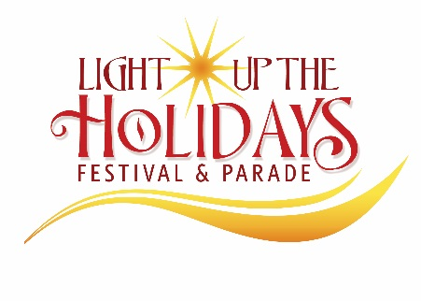

203 N. Ottawa St. Suite 100. ● Joliet, IL 60432-4232

Phone: (815)774-6066 ● ***www.jolietdowntown.com***

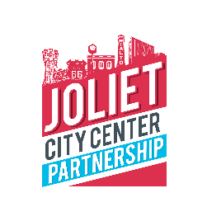





**2021 Light Up the Holidays Parade Registration**

Friday, November 26th, 2021 – kick-off at 5:30pm

_____ **Free Participant –** No charge for youth/school groups, Bands, Police, Fire, Honor Guards, or churches.

_____ **Professionally-built and decorated Christmas themed float $900**

*(Joliet City Center Partnerships makes the arrangements for you! Cost includes float, lighting, banner, delivery, and driver.)*

_____ **Large character balloon (limited amount available!) $450**

*(Joliet City Center Partnerships makes the arrangements for you! Cost includes balloon and transportation of balloon to/from and during the parade. Banner with Company name and logo will be 100.00 additional cost)*

_____ **Construct and enter my own float $100**

Describe size: _____________________________________________________________________________

***Contact Information (Please Print Clearly)***

Name: _______________________________________ Phone: __________________________________________

Organization Name: _________________________________________________________________________________

E-Mail Address: ____________________________________________________________________________________

***General Information:***

***REQUIRED: Please provide a brief (1-2 sentence) description of your group that will be used by the TV announcers.***

***We may edit your submission for length/clarity.***

__________________________________________________________________________________________

__________________________________________________________________________________________

Registration may be faxed to (815)723-6972 or sent by email to: JaworskiMary110@gmail, please make all checks payable to ***Joliet City Center Partnership***, 203 N. Ottawa St., Suite 100, Joliet, IL 60432.

If you have any questions or concerns, please call 815-474-1509.