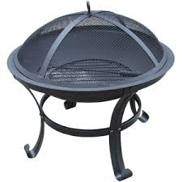**FIRE PIT CRITERIA** 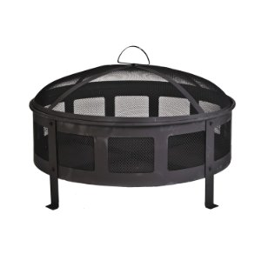

The Joliet Fire Department would like to remind residents the criteria for using a commercial fire pit within the city limits.

* Commercially sold steel outdoor fire pits that are on legs attached to a steel bottom, wire mesh sides and a top are approved.
* A fire extinguisher or garden hose must be available to extinguish the fire, if necessary.
* Approved outdoor pits shall be not less than 15 feet away from a structure of fence.
* Fuel (wooden logs or artificial logs) shall fit inside the confines of the wire mesh, and the top shall be in place to be legal. Wooden pallets, treated deck wood, leaves, dimensional lumber, or garbage shall not be used as fuel in an outdoor fire pit.
* Be aware that although it is legal to burn in an approved outdoor fire pit, if it is believed to be offensive or objectionable by the complainant due to smoke, flames, sparks, or odor omissions, then the homeowner shall extinguish the fire immediately. In addition, a police officer on the scene *may* issue a compliance ticket to the homeowner for creating a public nuisance or being in violation of the International Fire Code 2015 Section 307.4.3 “Prohibited Open Burning” which states: “Open burning that will be offensive or objectionable because of smoke or odor emissions when atmospheric conditions or local circumstances make such fires hazardous shall be prohibited. The fire code official is authorizes to order the extinguishment by the homeowner or the fire department of open burning which creates or adds to a hazardous or objectionable situation.”